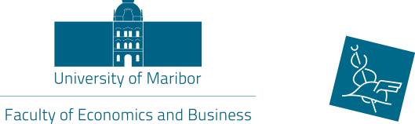
UNIVERSITY OF MARIBOR
Faculty of Economics and Busines
Razlagova 14, 2000 Maribor
Slovenia
International Relations Office

ERASMUS TRAINING in Maribor
„…let´s gain dynamic and positive experiences…“

Practical placement: Faculty of Economics and Business - International
Relations Office

Short description of main tasks:
- collaborating with foreign partners, universities and institutions
- administrative and other tasks, considering incoming and outgoing students
- activities in some international projects

Duration of training: 6 months

Beginning of training: 1th February 2022 – 1th August 2022
1st April 2022 – 1st October 2022
Conditions of payment: - Erasmus or other scholarship from home institution

Requirements: - CV with photo and Motivation Letter to one of the emails
mentioned below
- well proficient in English (at least B2 level)
- well proficient in computer programmes (Word, Excell,..)
- communicative and open minded person
- international experience
- field of study is not important

What do we offer: - all students benefits (food coupons,library),
- work in a pleasant and international environment
- lively and young atmosphere in the city of Maribor

Contact: International Relations Office Sanja Kocijan, MSc.
Tel: +386 2 22 90 252
E-mail: sanja.kocijan@um.si or feb.international@um.si

Deadline for application : 1st of November 2021

